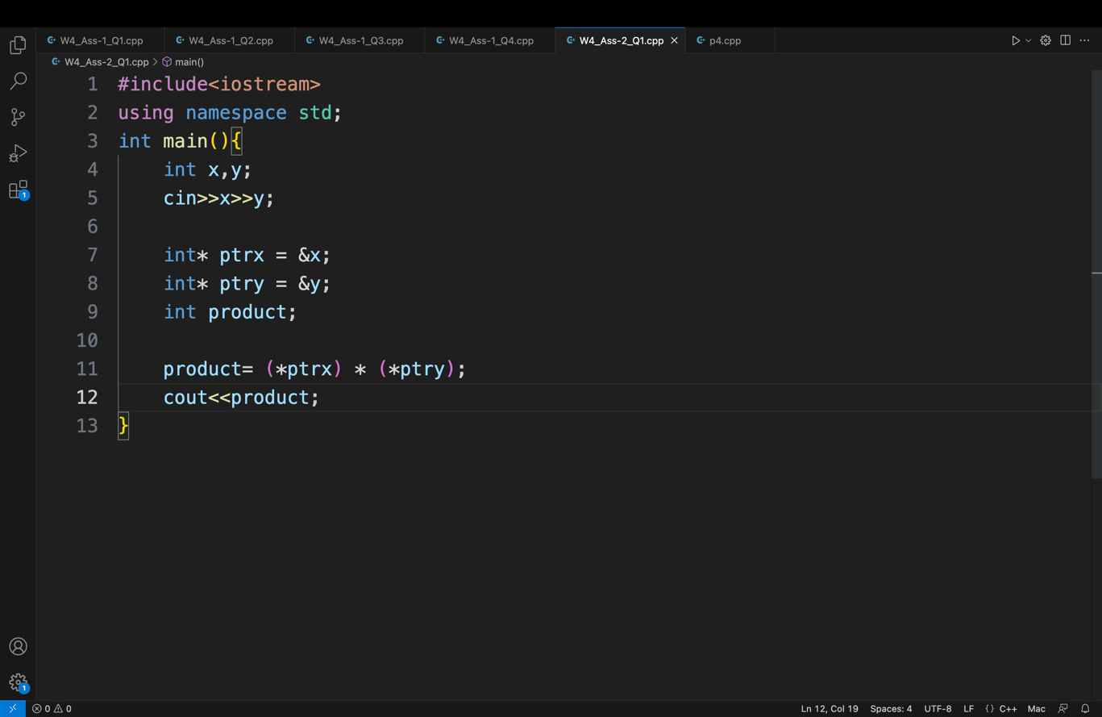  
Week 4 Assignment-2.

Q1.

Q2

p is a pointer and q is an integer. \* is grouped with variables, not data types.

Q3.

11 10 11 ptr points to a, b = a + 1 , so ptr points to b

Q4.

a gets the value of b

Q5.

The program is correct and will compile but might result in runtime error. This is

because pointer will have a garbage address which might even point to a location which

does not belong to our program and hence might result in Segmentation Fault when we

are trying to access it.